
A 10

Sreenidhi Institute of Science & Technology
(An Autonomous Institution)
Code No: 102EP01
M. TECH. I – Year I – Semester Examinations, March, 2011 (Regular)
POWER SYSTEM DYNAMICS (EPE)

Time: 3 Hours Max. Marks : 60

Note : No additional answer sheets will be provided.

* * * * *
Part-A (Objective Type)
Max.Marks:10

ANSWER ALL THE QUESTIONS. EACH QUESTION EQUAL MARKS.

1. Give an example for sudden and large disturbance.

2. Explain the need for Park's transformation.

3. Draw d-axis equivalent circuit of synchronous machine.

4. Draw the block diagram representation of a static excitation system.

5. Write stator voltage equation of model 1.1.

6. Write any two assumption in equal area criteria.

7. Explain the effect of loading on K₅ constant in Heffrow - phillips model.

8. Write major criterion for stability for low values of K_{E}.

9. Write significance of wash out terms in PSS.

10. Give atleast two control signals used as input signal to PSS.

Part – B (Subjective Type)
Max.Marks: 50
Answer any Five. All questions carry equal marks.

1. a) Derive swing equation. [ 5 ]

b) A 50 Hz synchronous generator having constant H =2.5 MJ / MVA and X|d = 0.3 p.u. is connected to an infinite bus through a purely reactive network as shown in figure below. The generator is delivering P_{e0}=0.8 p.u. and Q = 0.1 p.u to infinite bus at voltage of 1.0 ∠0. A temporary three phase fault occurs at point F. when the faculty is cleared both the lines are intact. Find critical clearing angle. [ 5 ]

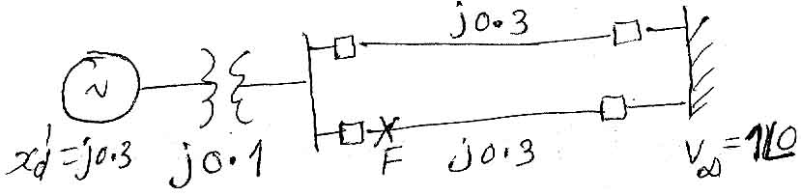

2. a) Prove that electrical torque in a synchronous machine under loaded
condition. [ 6 ]
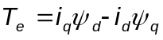
b) Form d - axis equivalent circuit find expression for [ 4 ]
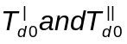
3. Derive state space representation of IEEE type - 1 excitation system. [ 10 ]

4. Obtain the transformation matrix for the following
a) Stator voltage equations. [ 5 ]
b) torque equations. [ 5 ]

5. a) From overall block diagram representation of rotor swing equation, fluse decay and excitation system determine the conditions to get synchronizing and damping torques positive for all frequencies. Neglecting AVR. [ 6 ]

b) For the system in (a) find conditions for synchronizing and damping torques to the positive. when high gain static excitation system is used.
[ 4 ]
6. a) Explain [ 2 ]
i) intra plant mode of oscillations.
ii) Local mode of oscillations.

b) From simplified model of SMIB system derive an expression for GEP (S) and explain how to design dynamic compensator to compensate for phase log by GEP (S). [ 8 ]

7. Write short notes on
a) Per unit quantities. [ 5 ]
b) Application of Routh - Hurwitz analysis for SMIB system. [ 5 ]

------

